**Assignment 1**

**Database Documentation:** [**https://dev.mysql.com/doc/sakila/en/**](https://dev.mysql.com/doc/sakila/en/)

**Tables:** [**https://dev.mysql.com/doc/sakila/en/sakila-structure-tables.html**](https://dev.mysql.com/doc/sakila/en/sakila-structure-tables.html)

**Perform the following queries:**

1. Retrieve all records from film table

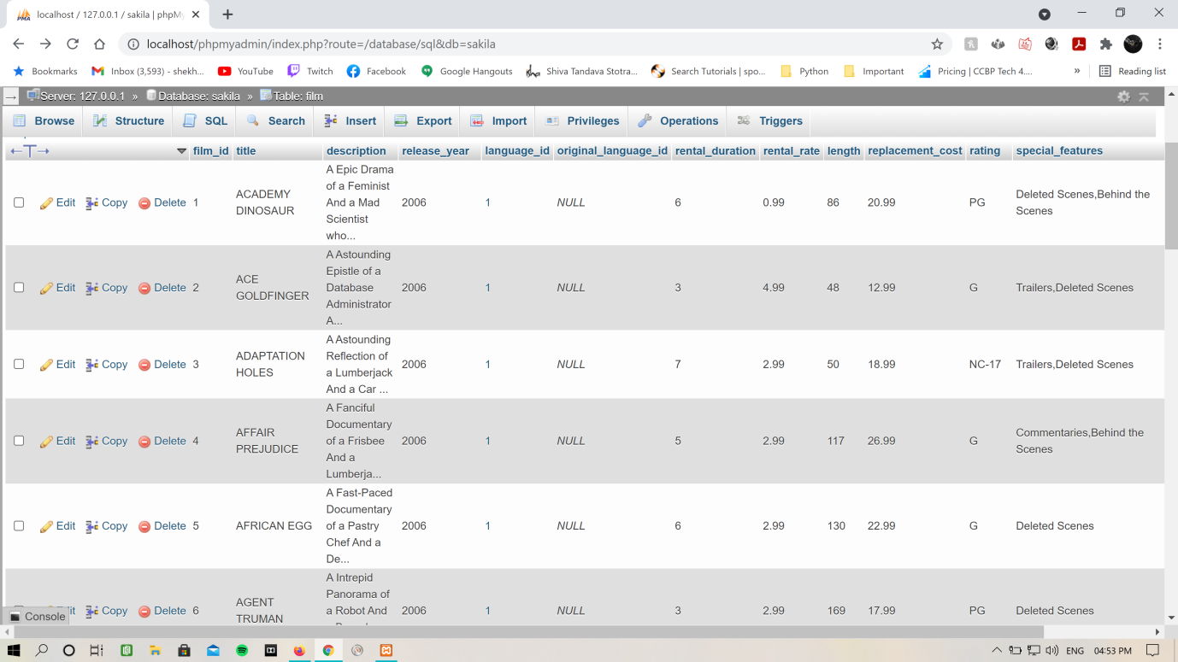

1. Retrieve title, rental_duration, rating, special_features of all films

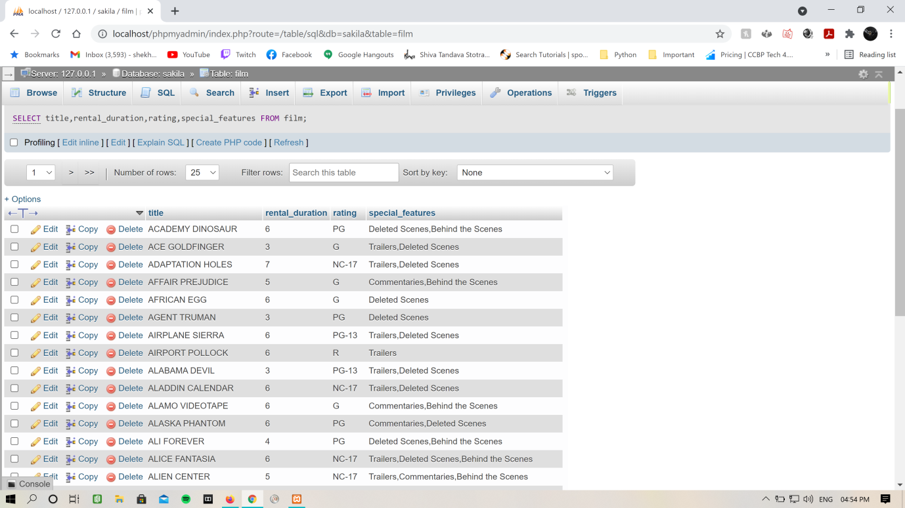

1. Retrieve titles and ratings of all films having 'PG' rating

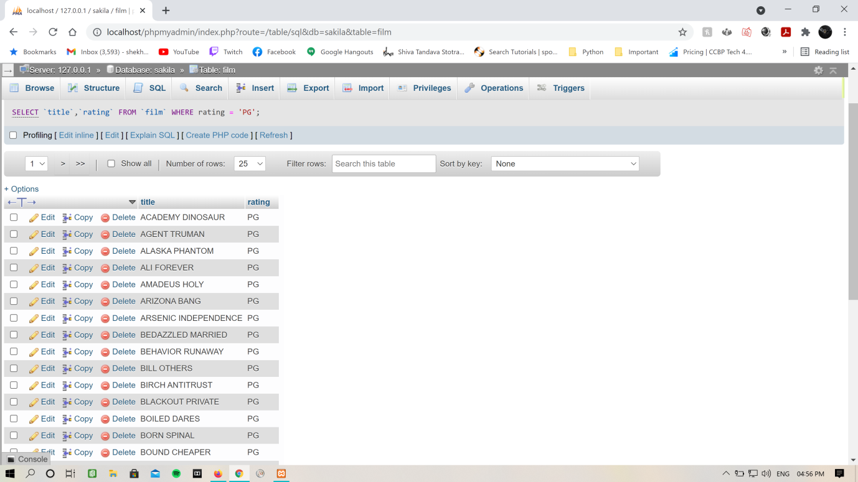

1. Retrieve titles of all films having 'G' rating and rental_duration is 3

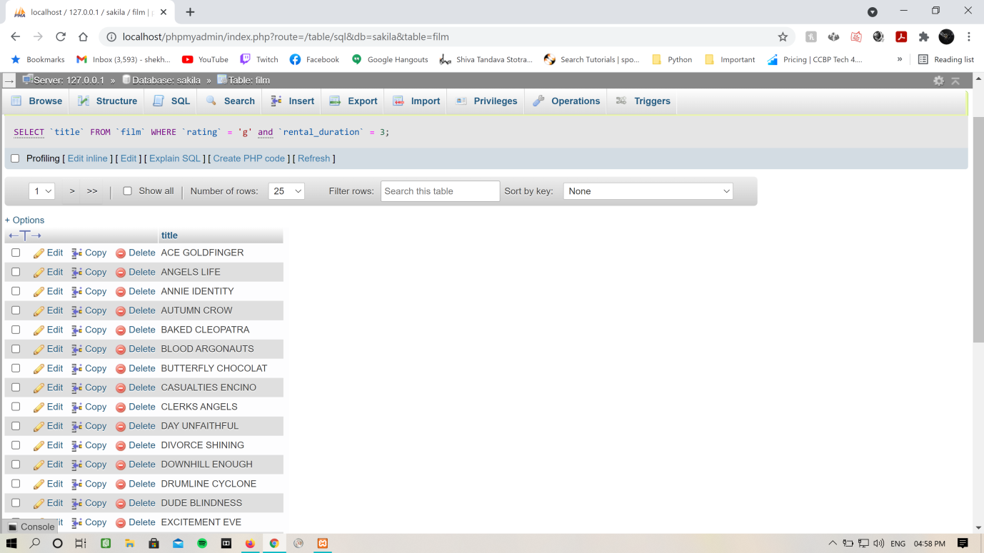

1. Retrieve all records from films for which replacement_cost is less than or equal to 9.99 dollars

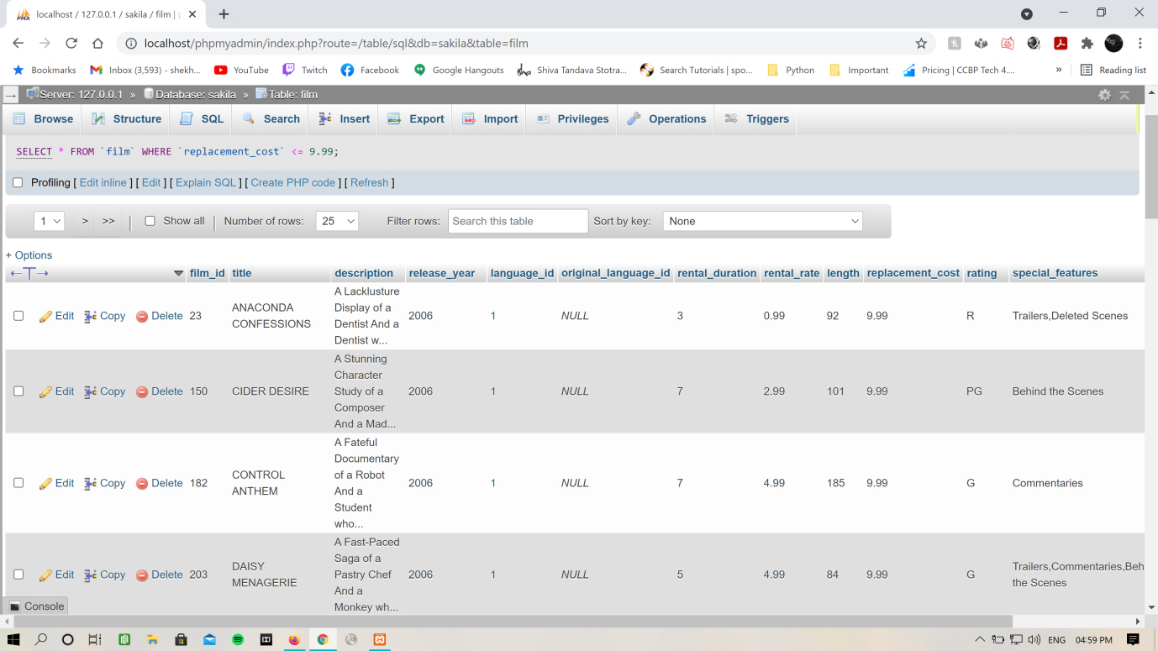

1. Find out the film titles and rental duration of all films which are allowed to rent between 4 to 6 days

(Use between)

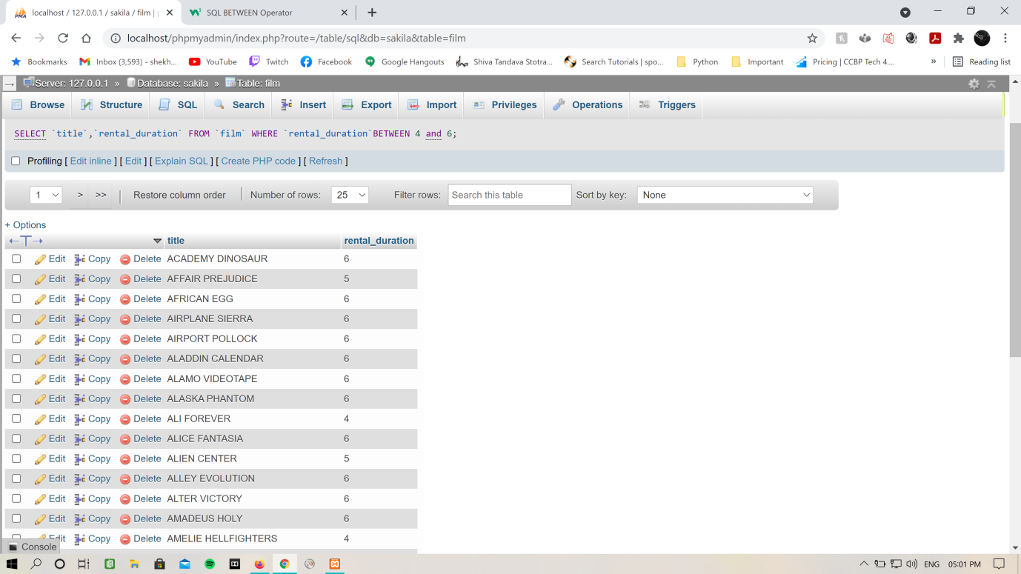

1. Find out the film titles and rental duration of all films which are allowed to rent between 4 to 6 days

(Without using between)

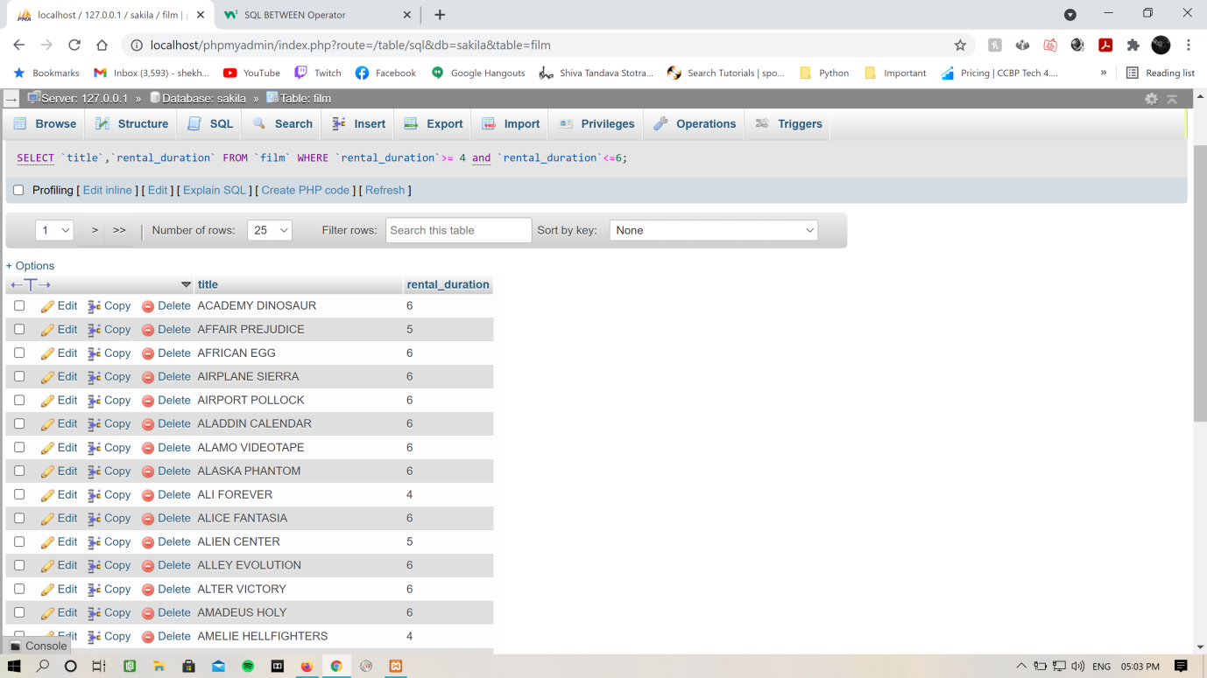

1. Retrieve all film titles, special features and ratings of the films for which only commentaries is available

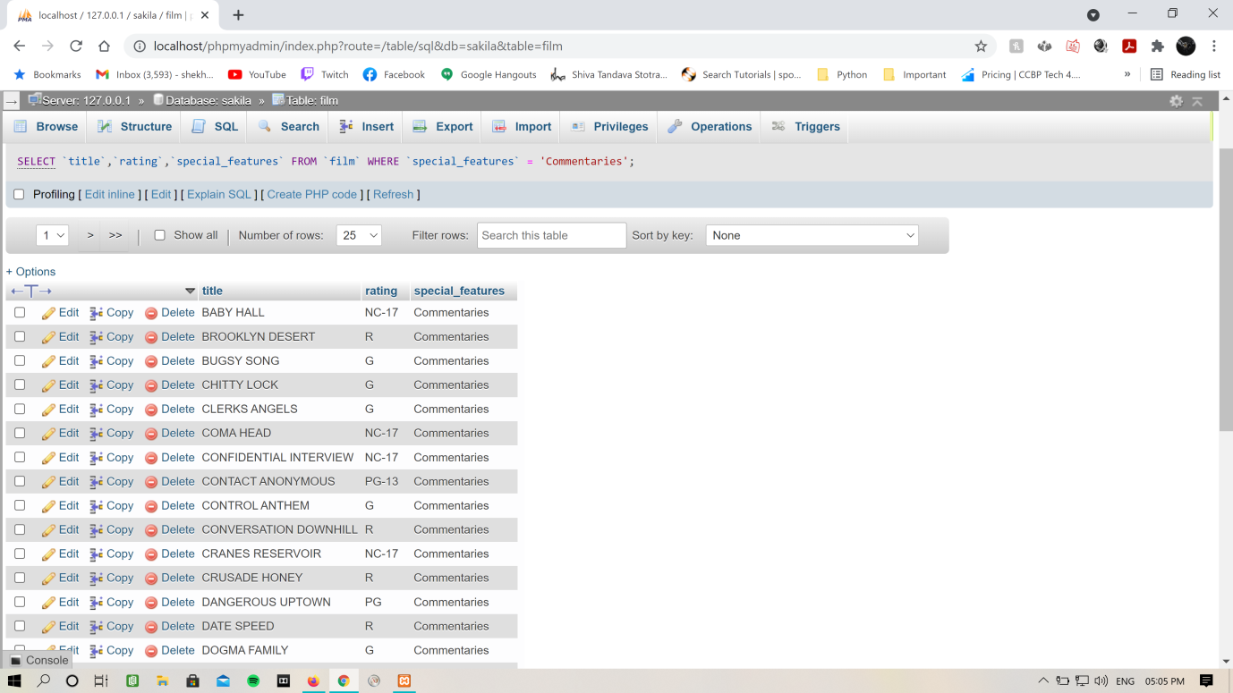

1. Retrieve all film titles, special features and ratings of the films for which "commentaries" is a part of special_features

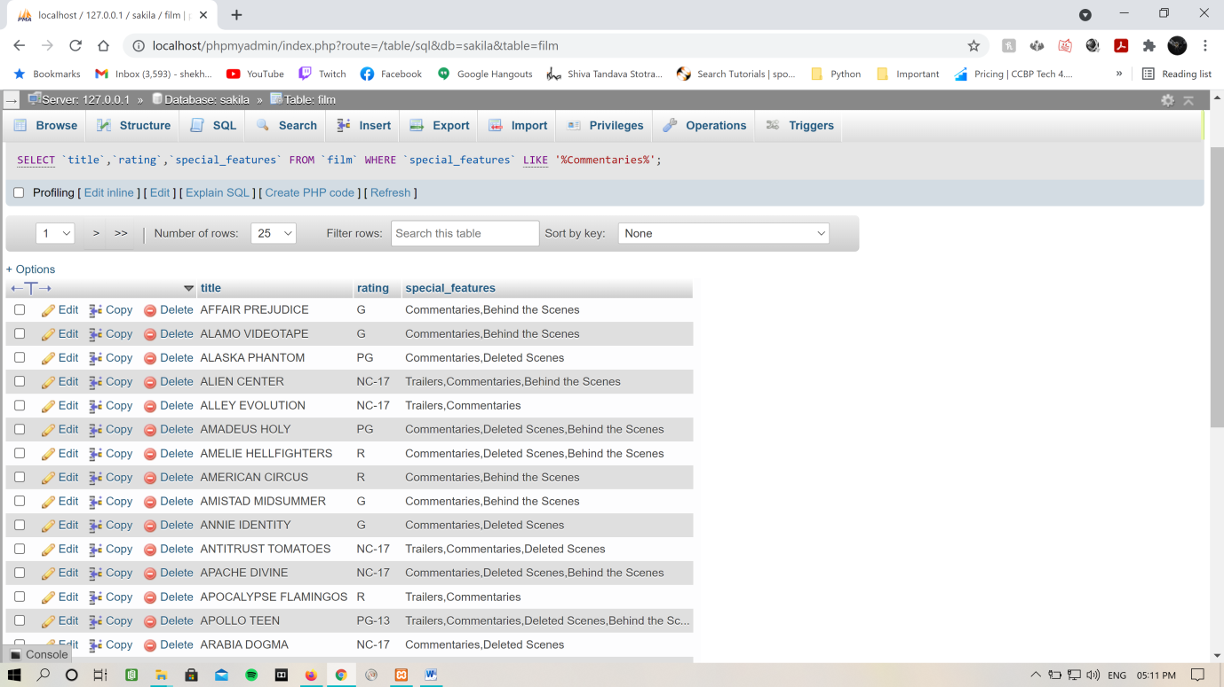

1. Retrieve all the films for which rating is either G, PG or PG-13

(without using logical operators)

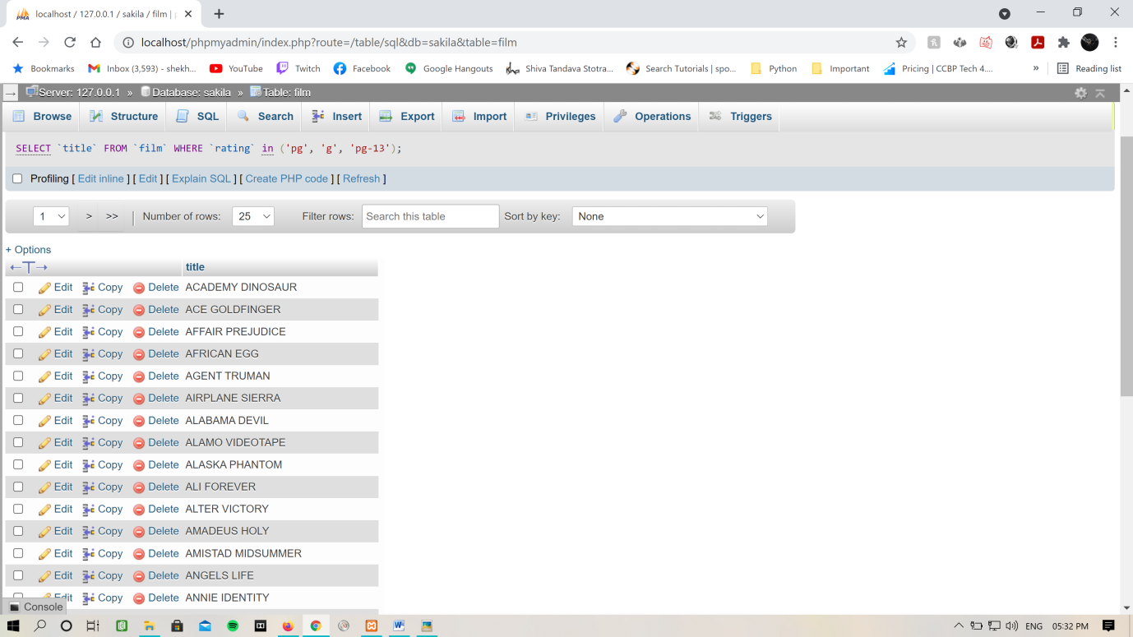

1. Retrieve titles of all films having rating either "G", "PG" or "PG-13" and rental_duration is either 3, 5 or 7

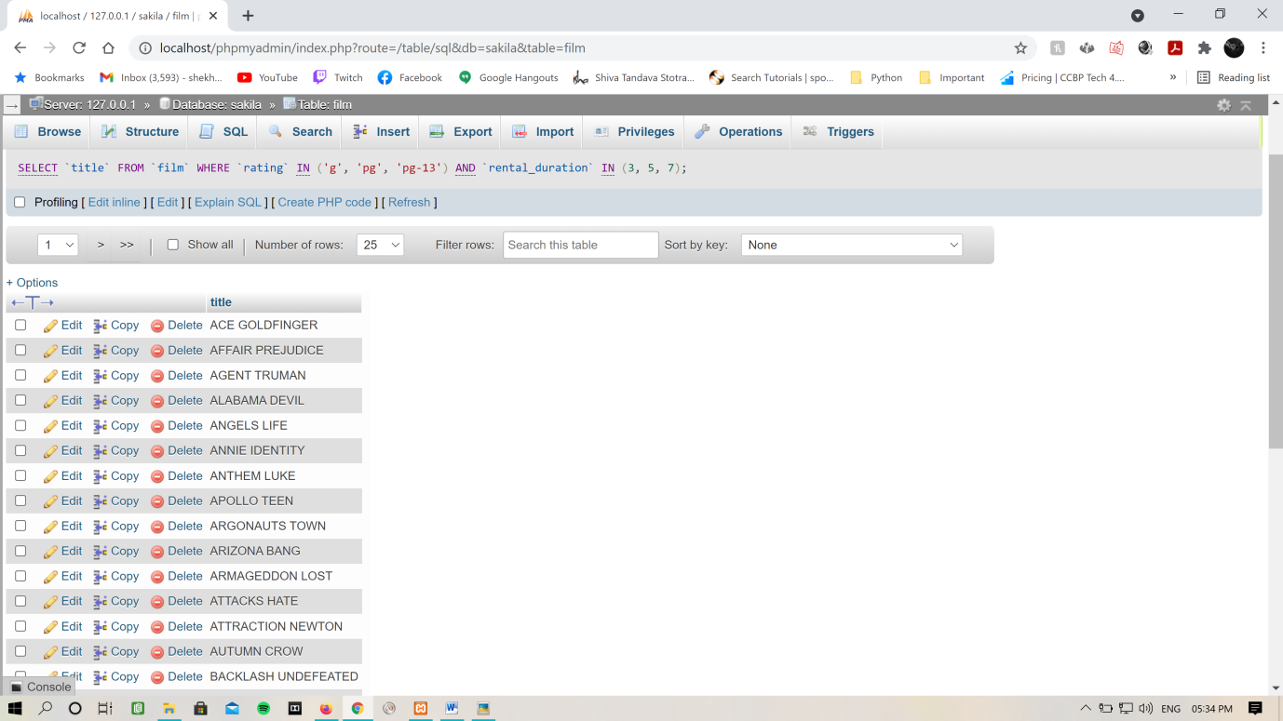

1. Find titles of all movies whose names start with A and ends with R

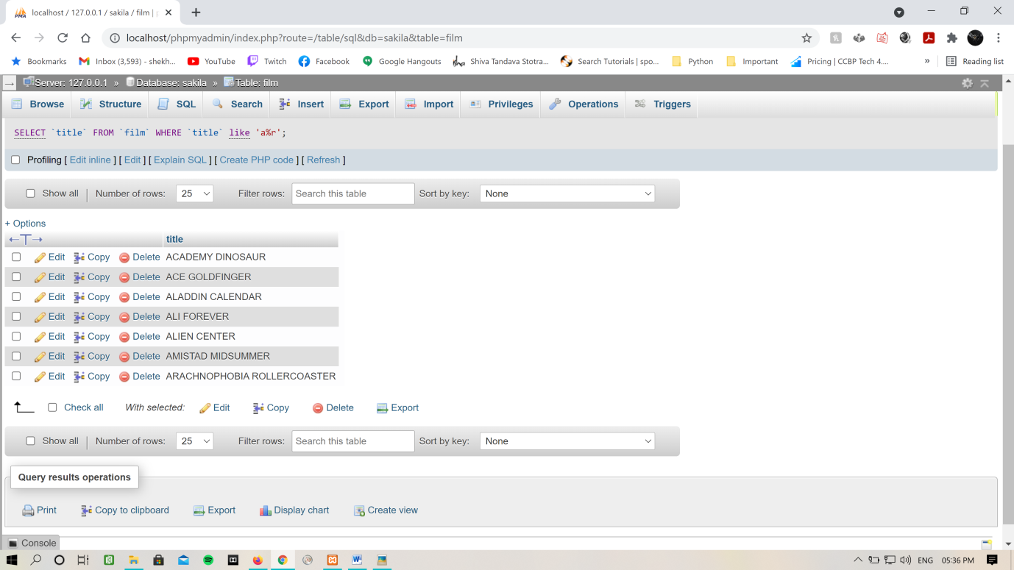

1. Find titles of all movies which contains a substring with first letter 'C' and third letter 'N'

(e.g. American, Anaconda)

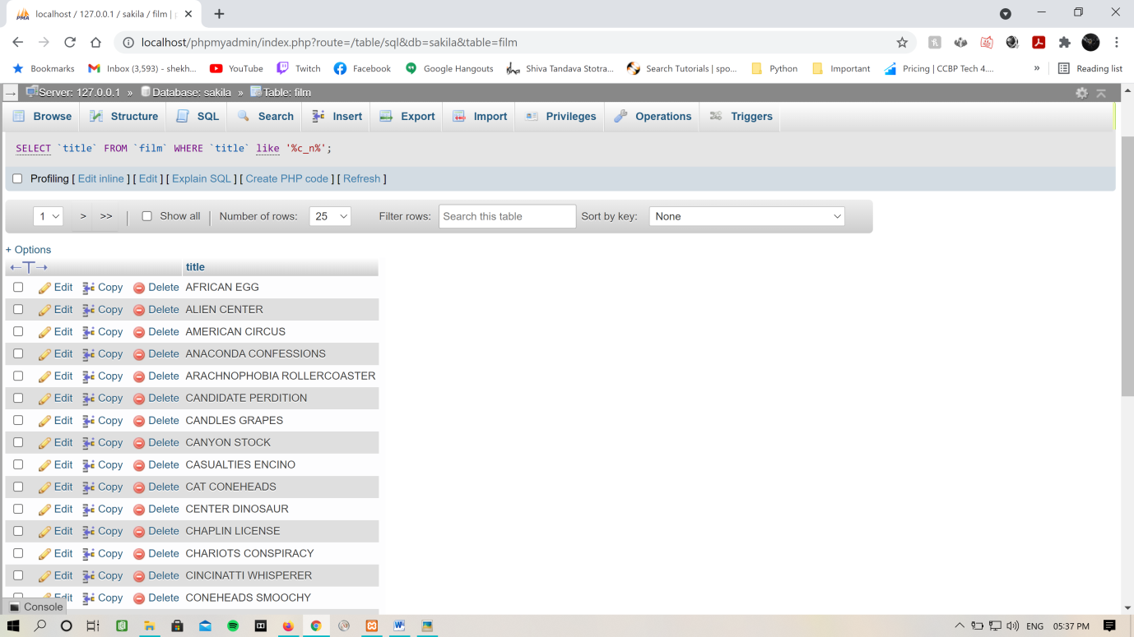

1. Display titles, ratings and rental durations of all the films which starts with S, which is available for rent for more than 6 days and rating is either G or PG. Also display the result in descending order of titles

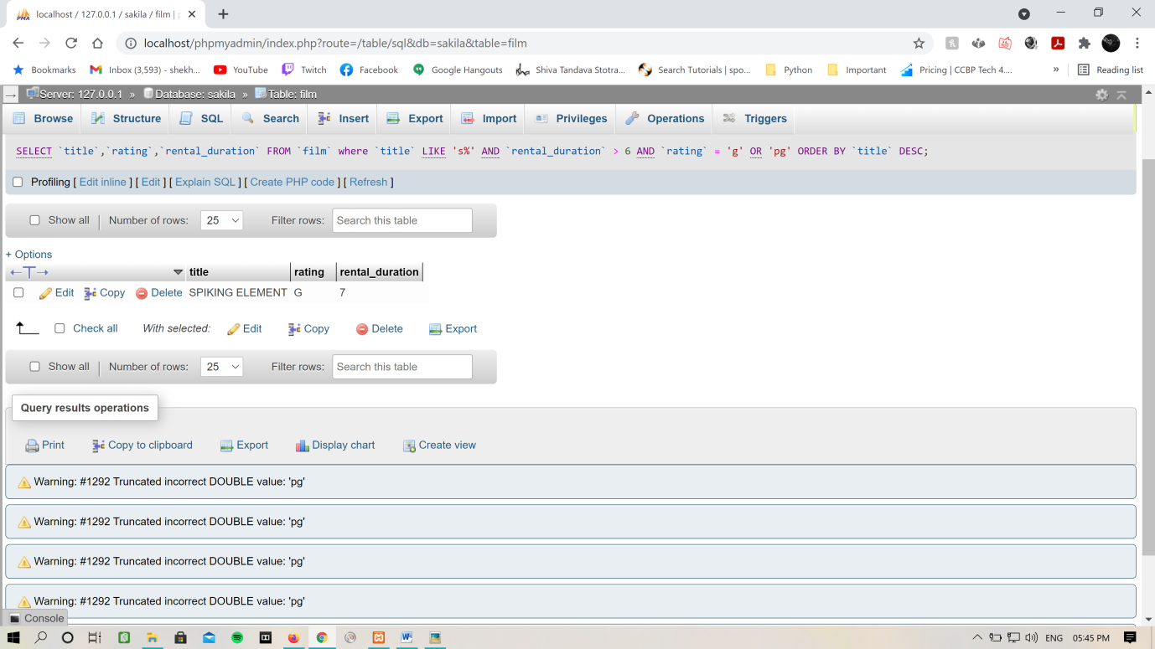

1. Display titles, ratings and rental durations of all the films for which "commentaries" is a part of special_features, and rating is either G, PG or PG-13. Also display the result in ascending order of rental durations

